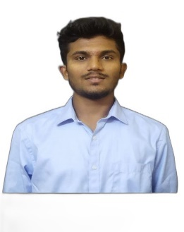Shivaraj S H 

CSD Intern

Email ID: 2318952@cognizant.com

Mobile: +918792088803

Address: Narayan PG, Sambalal Street, Navalur, Chennai-600032, Tamil Nadu.

LinkedIn: https://www.linkedin.com/in/shivaraj-s-h-70b771264

**CAREER OBJECTIVE**

Looking forward to associating myself with an organization, where there is an opportunity to share, contribute and upgrade my knowledge for the development of self and organization served.

**WORK EXPERIENCE**



**CSD Intern | Dec 2023 – Present**

Currently undergoing training program on ADM Java FSE where I’m learning Java, SQL, Spring, Hibernate, HTML, CSS, react programming courses, gaining strong core and technical knowledge in these courses.

**ACADEMIC QUALIFICATION**

* **KLE Technological University Hubballi.**

BE, Electrical and Electronics | Aug 2019 – 2023 | CGPA – 8.00

* **Jawahar Navodaya Vidyalaya Dharwad.**

Class 11TH & 12TH PUC | 2016 – 2018 | 88%

* **Jawahar Navodaya Vidyalaya Dharwad.**

SSLC | 2016 | CGPA –9.4.

**PROFESSIONAL SKILLS**

* Software skills known: Working knowledge in MATLAB, Proteus.
* Programming skills known: Basics of SQL, JAVA.
* Adapting to any environment or culture.
* Ability of willingness to learn new things.
* Ability to work independently or as a part of a team.
* Hard worker and has the ability to motivate myself and others.
* Good at oral and written communication

**PROJECT WORK**

* **Employee Management System**

This system is designed to automate HR tasks, making the process more efficient and error-free. It allows HR managers to focus on strategic tasks by reducing the time spent on administrative tasks. The Employee Management System is a crucial tool for any organization aiming to streamline its HR operations.

**WORKSHOPS & CERTIFICATIONS**

* Completed IIOT course and certified from GTTC Hubli.
* Completed PLC/SCADA course and certified from GTTC Hubli.

**PERSONAL DETAILS**

* Languages known : English, Kannada, Hindi.
* Domain Interests : Programming, Testing and validating.
* Hobbies : Playing outdoor games, Travelling.